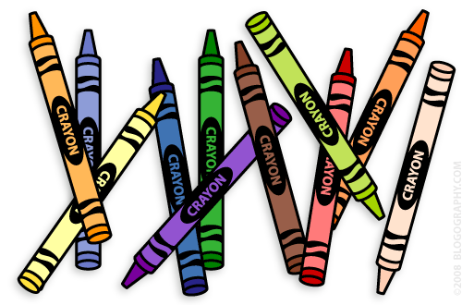**Our 1st Grade Classroom News**

**The Week of September 5th – 8th**

**Email:** [**Lweeks@bluevalleyk12.org**](mailto:Lweeks@bluevalleyk12.org)

**Website:** [**https://teachers.bluevalleyk12.org/Domain/559**](https://teachers.bluevalleyk12.org/Domain/559)

* Library checkout is on Thursday afternoons. If you could help your child to remember to bring back their library books that day, that would be great!
* Field trip lunch forms for the zoo field trip were sent home on Friday, September 1st. If you would like your child to eat a school lunch that day, please fill it out and send it back to school by September 14th.

**Important Info**

Sept. 1st Reading Logs Start

Sept. 4th No School

Sept. 14th Field Trip lunch orders are due

Sept. 22nd No School

Sept. 29th Zoo Field Trip

**Upcoming Events**

**Math Challenge of the Week:**Have your child come up with story problems that includes 2 things joining together. For example: I have 8 lollipops. Then my friend gave me 4 more. How many lollipops do I have now? If needed, you can write the story out that your child tells you.*You can make this as hard (higher numbers) or easy (lower numbers) as you think your child can handle. You could also have them use more than 2 numbers.*  
  
**Reading Challenge of the Week:**During reading groups, we are talking about 5 strategies to use when they get stuck on a word. ***1.****Put your finger under the word.****2.****Get your mouth ready****3.****Think about what makes sense.****4.****Look at the picture.****5.****Find a chunk in the word that you know.* While reading with your child this week, see which strategy your child used when they got stuck on a word. They may have had to use more than 1 strategy on a word! Have them write about which strategy they used! *For more of a challenge, have a student find a super challenging word in the dictionary and try to pronounce it. What word did they choose? What strategy helped them?*  
**Writing Challenge of the Week:** Finding a comfortable place to write can help your child write better sometimes. Have your child find a comfortable place to write around your house. Where did they decide to write? What materials did they bring with them to their writing spot? Did it help them write better? Have your child write down where they picked to write and what things they brought with them!

**Tech of the Week**

**Website of the Week:** Forming Sentences is a great website for 1st graders with beginning writing skills. This will help them identify the order of words and reinforce capital letters and punctuation marks. <http://www.softschools.com/language_arts/games/sentence_structure/form_a_sentence/>

**App of the Week**: [World Book Animals](http://itunes.apple.com/us/app/world-books-world-of-animals/id441771838?mt=8)is a fantastic app for students that love learning about animals! Students can click different pictures of animals and find videos, pictures, and information about that animal. There are TONS of animals to explore and really neat information about them. This one does cost some money so I definitely would take a look at it on the app store and see if it is worth it to you to buy.

**Challenges of the Week**